**GIT Assignment:**

Q1: Create a local git repository in your local machine first. Commit the initial code

Created a directory in local machine.

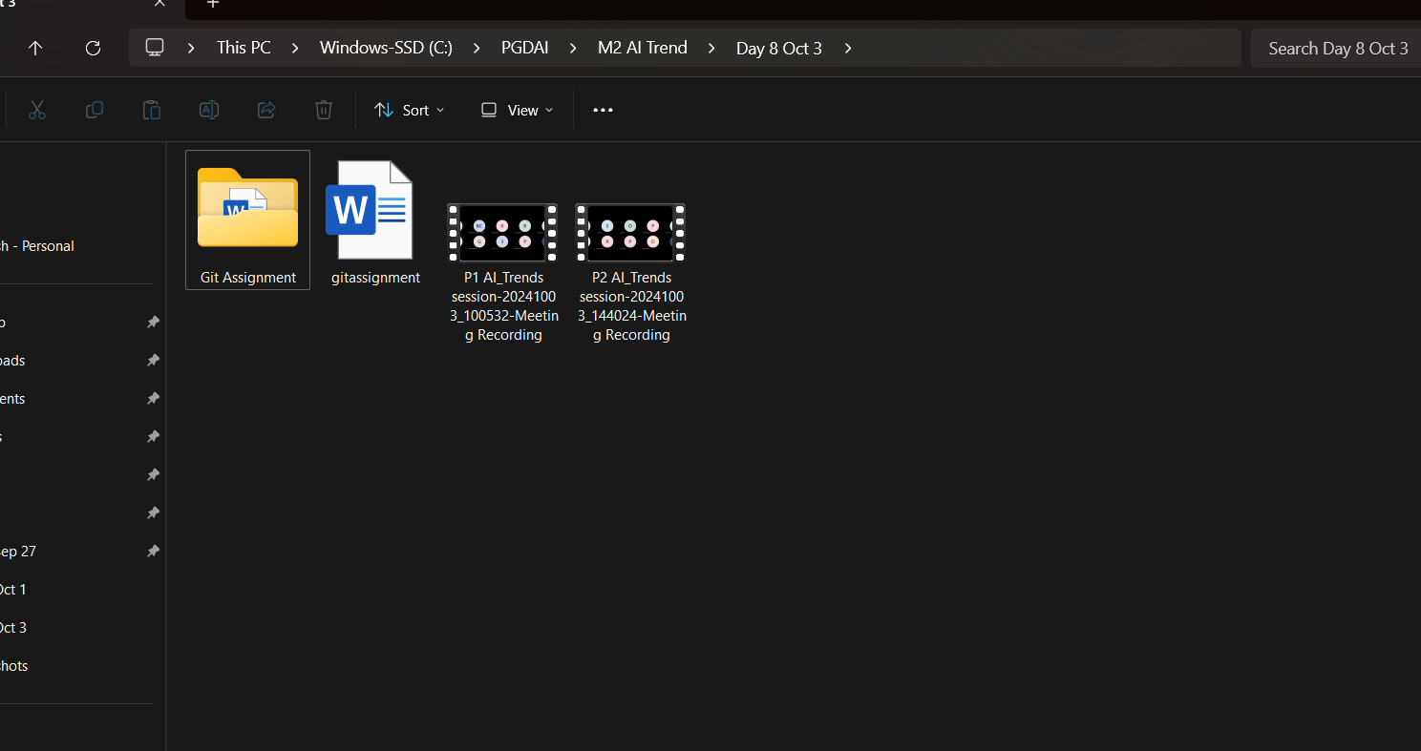

Initialize and listed of git files in folder => git init & ls -a

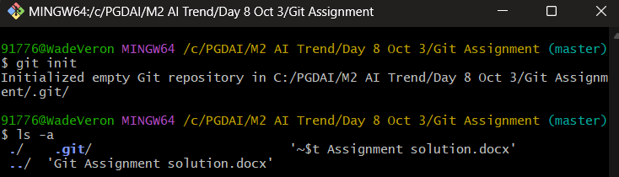

Created a new repository on github

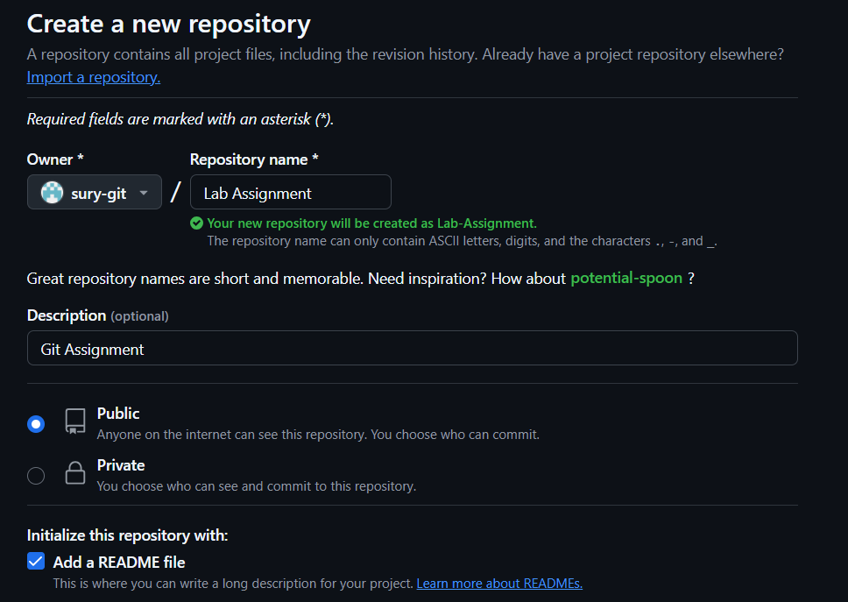

Connect the local repo to remote repo => git remote add origin [https://github.com/sury-git/Lab-Assignment.git](https://github.com/sury-git/Lab-Assignment.git)